Task 4

1. Explore on free command free –h command ?

Sol : free : It displays the information about the system memory usage.

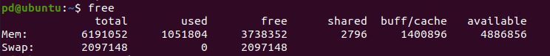

Sol : free -h (h = human readable) : It displays the information about the system memory usage in human readable format in units like KB, MG and GB.

